Octagonal Bipyramid

Definition
# Source: AI Source: Provided by: [Data Path: Persons Table -> ID Column: 1, Name_En Column: Motasem Essam] -> From: [ChatGPT] on [7/25/2026]
An Octagonal Bipyramid is a three-dimensional polyhedron formed by joining two octagonal pyramids at their congruent octagonal bases. The shared octagonal base becomes an internal face, while the triangular lateral faces form the exterior surface.
It consists of:
- Two apexes positioned on opposite sides of a common octagonal base.
- Eight vertices forming the shared octagonal base.
- Sixteen external triangular faces.
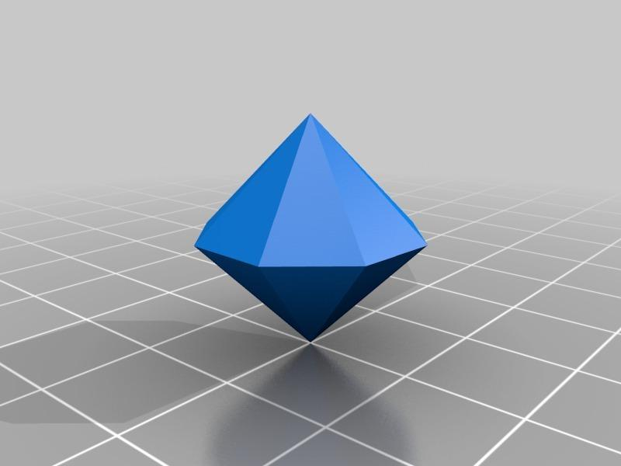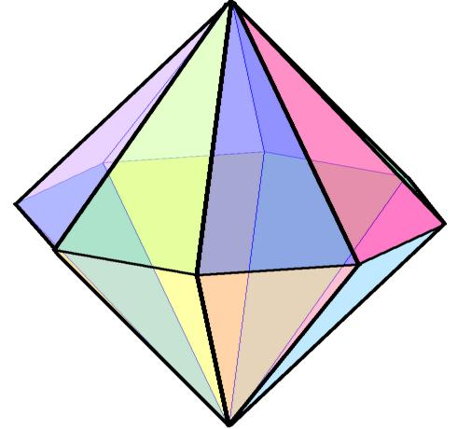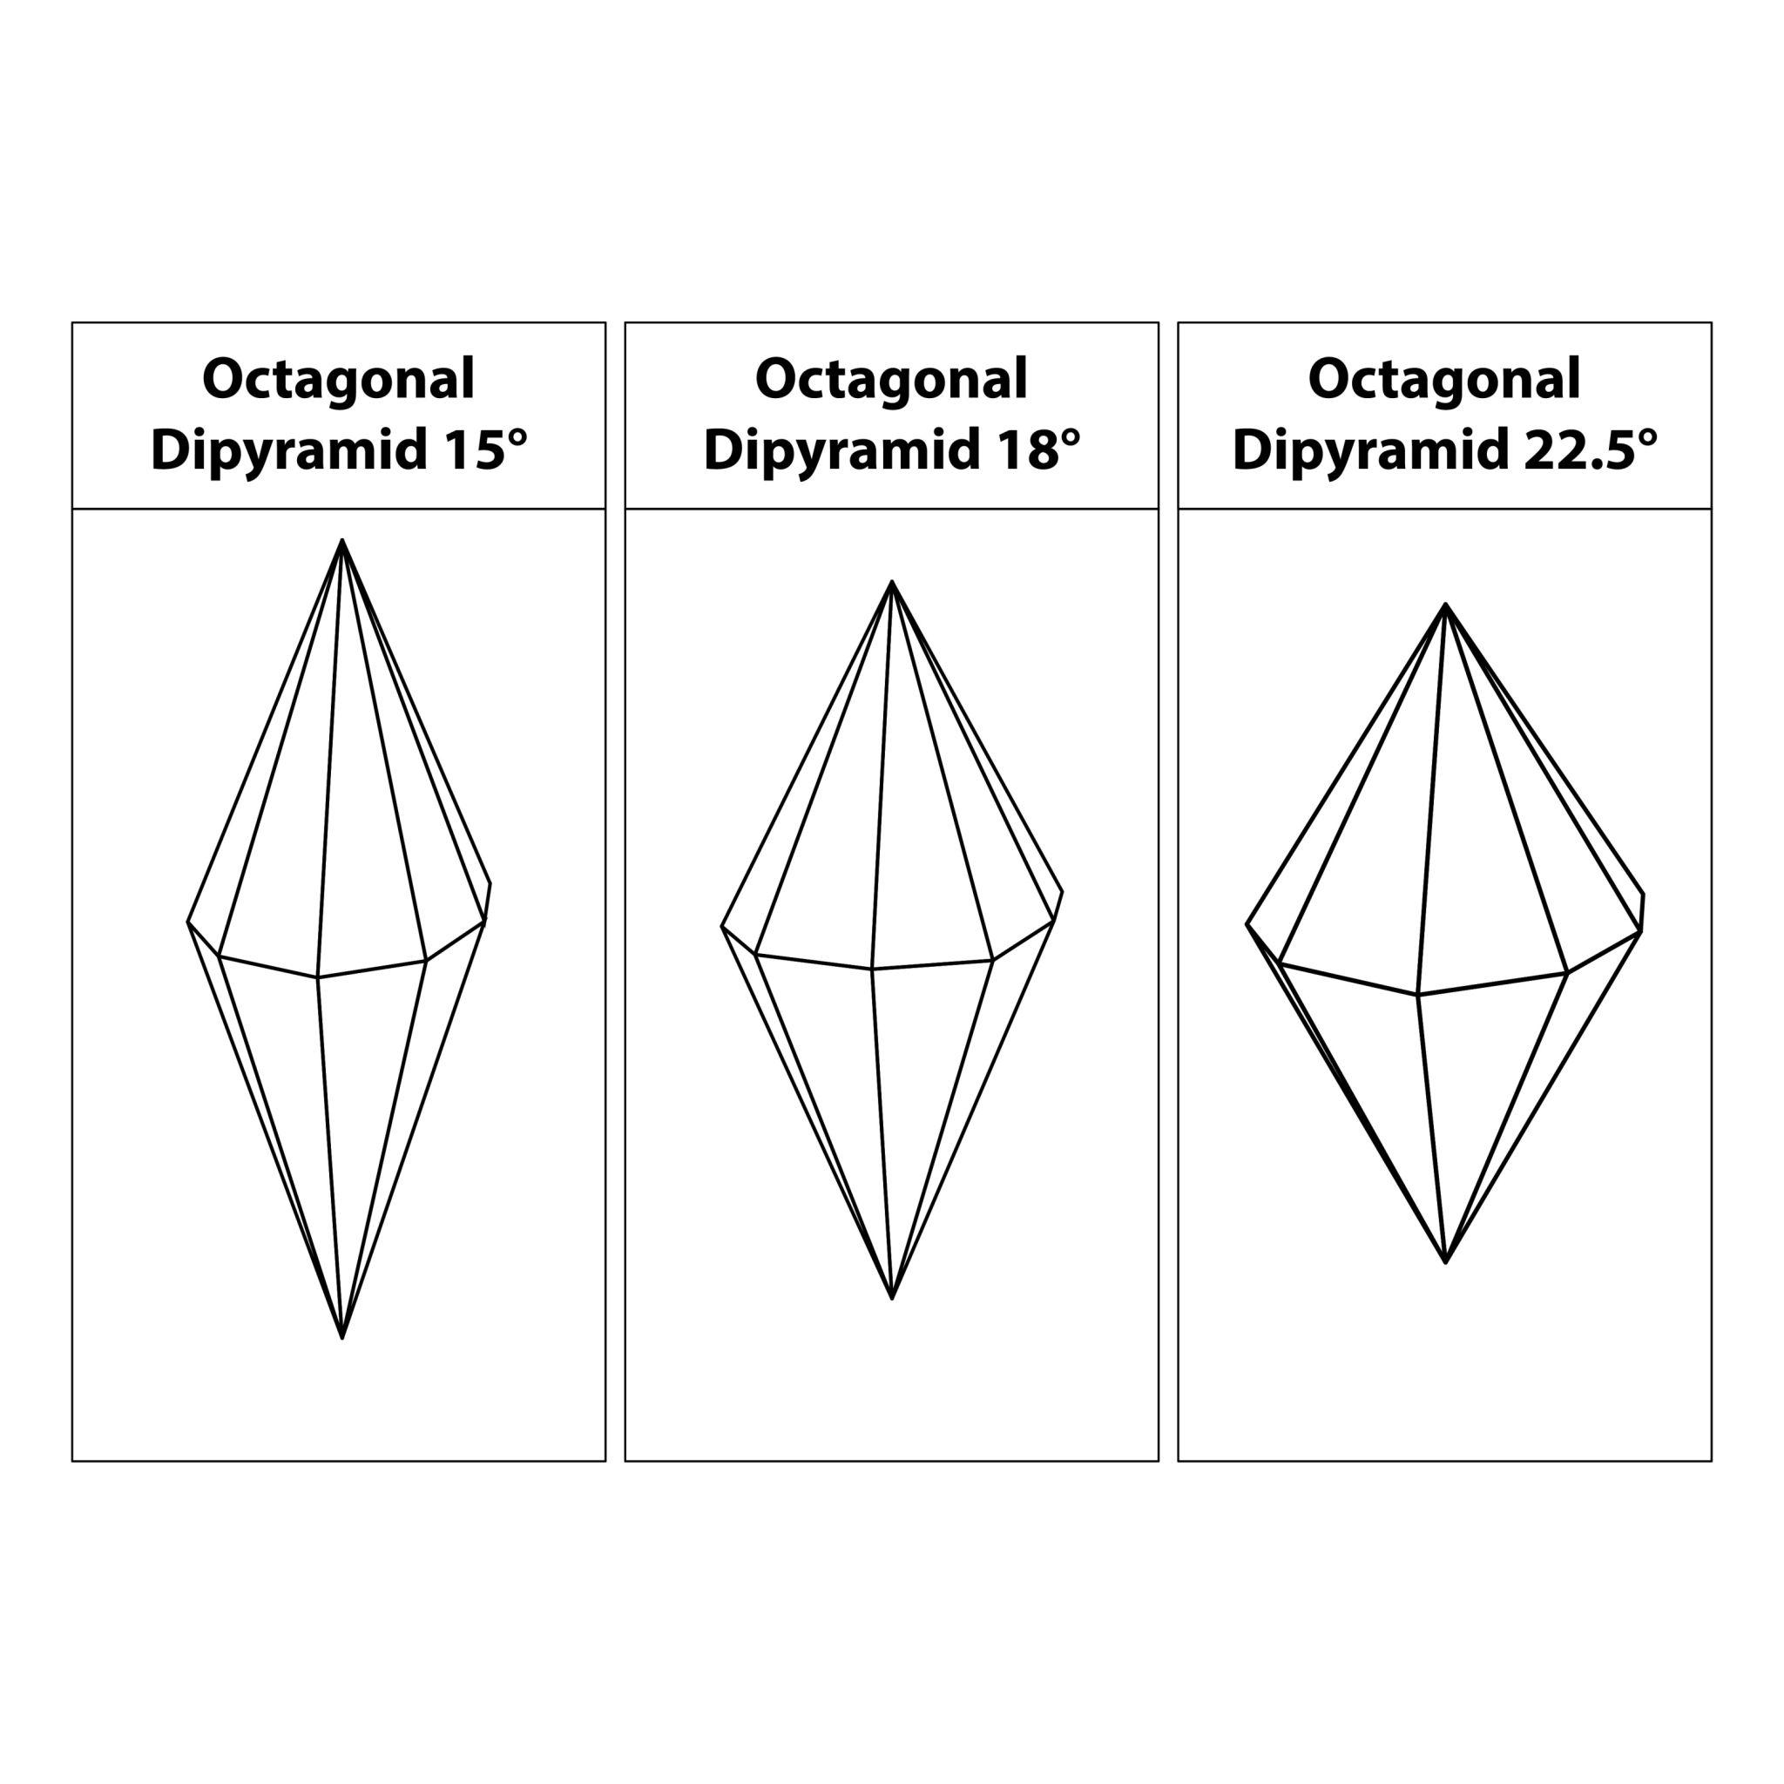

Simple Definition
# Source: AI Source: Provided by: [Data Path: Persons Table -> ID Column: 1, Name_En Column: Motasem Essam] -> From: [ChatGPT] on [7/25/2026]
An octagonal bipyramid is a solid made by joining two octagonal pyramids base-to-base, creating a polyhedron with 16 triangular faces, 24 edges, and 10 vertices.

Geometric Structure
# Source: AI Source: Provided by: [Data Path: Persons Table -> ID Column: 1, Name_En Column: Motasem Essam] -> From: [ChatGPT] on [7/25/2026]
The octagonal bipyramid has three main structural components:
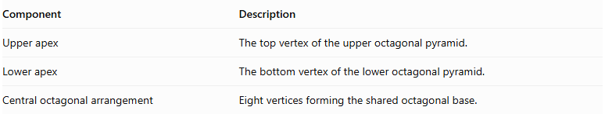
Component | Description
Upper apex | The top vertex of the upper octagonal pyramid.
Lower apex | The bottom vertex of the lower octagonal pyramid.
Central octagonal arrangement | Eight vertices forming the shared octagonal base.
Both apexes are connected to all eight vertices of the central octagon.

Face Structure
# Source: AI Source: Provided by: [Data Path: Persons Table -> ID Column: 1, Name_En Column: Motasem Essam] -> From: [ChatGPT] on [7/25/2026]
An octagonal bipyramid has 16 external triangular faces.
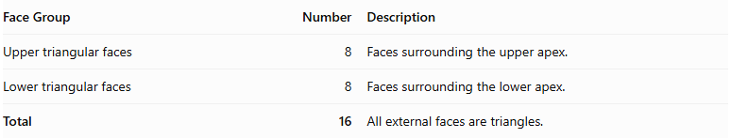
Face Group | Number | Description
Upper triangular faces | 8 | Faces surrounding the upper apex.
Lower triangular faces | 8 | Faces surrounding the lower apex.
Total | 16 | All external faces are triangles.
The common octagonal base is internal, so it is not counted as an external face.

Edge Structure
# Source: AI Source: Provided by: [Data Path: Persons Table -> ID Column: 1, Name_En Column: Motasem Essam] -> From: [ChatGPT] on [7/25/2026]
The solid has 24 edges, divided into three groups:
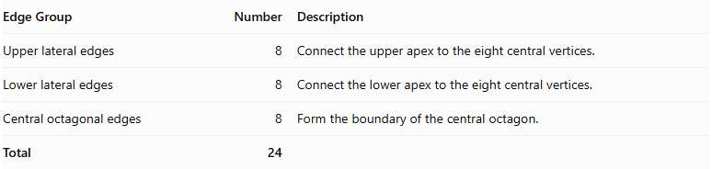
Edge Group | Number | Description
Upper lateral edges | 8 | Connect the upper apex to the eight central vertices.
Lower lateral edges | 8 | Connect the lower apex to the eight central vertices.
Central octagonal edges | 8 | Form the boundary of the central octagon.
Total | 24

Vertex Structure
# Source: AI Source: Provided by: [Data Path: Persons Table -> ID Column: 1, Name_En Column: Motasem Essam] -> From: [ChatGPT] on [7/25/2026]
An octagonal bipyramid has 10 vertices.
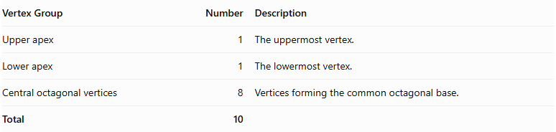
Vertex Group | Number | Description
Upper apex | 1 | The uppermost vertex.
Lower apex | 1 | The lowermost vertex.
Central octagonal vertices | 8 | Vertices forming the common octagonal base.
Total | 10

Mathematical Properties
# Source: AI Source: Provided by: [Data Path: Persons Table -> ID Column: 1, Name_En Column: Motasem Essam] -> From: [ChatGPT] on [7/25/2026]
For an octagonal bipyramid:
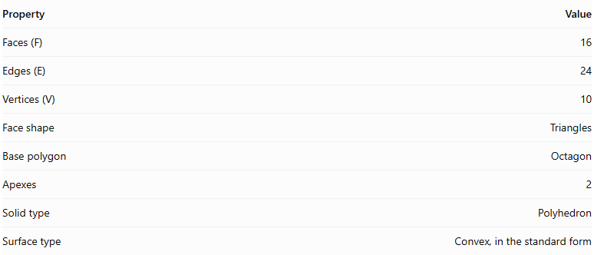
Property | Value
Faces (F) | 16
Edges (E) | 24
Vertices (V) | 10
Face shape | Triangles
Base polygon | Octagon
Apexes | 2
Solid type | Polyhedron
Surface type | Convex, in the standard form
It satisfies Euler's polyhedron formula:
$$V-E+F=2$$
$$10-24+16=2$$

Face Incidence
# Source: AI Source: Provided by: [Data Path: Persons Table -> ID Column: 1, Name_En Column: Motasem Essam] -> From: [ChatGPT] on [7/25/2026]
In the standard octagonal bipyramid:
- Each apex is shared by 8 triangular faces.
- Each central octagonal vertex is shared by 4 triangular faces.

Surface Area and Volume

Surface Area
# Source: AI Source: Provided by: [Data Path: Persons Table -> ID Column: 1, Name_En Column: Motasem Essam] -> From: [ChatGPT] on [7/25/2026]
The total surface area is the sum of the areas of the sixteen external triangular faces.
$$SA=8A_{u}+8A_{l}$$
Where:
- $A_{u}$ = area of one upper triangular face.
- $A_{l}$ = area of one lower triangular face.
If the upper and lower pyramids are congruent:
$$SA=16A_{t}$$
For an octagonal bipyramid with identical triangular faces, where each triangle has base side length $s$ and slant height $l$:
$$SA=16(\frac{1}{2}sl)$$
$$\boxed{SA=8sl}$$

Volume
# Source: AI Source: Provided by: [Data Path: Persons Table -> ID Column: 1, Name_En Column: Motasem Essam] -> From: [ChatGPT] on [7/25/2026]
The volume is the sum of the volumes of the two octagonal pyramids.
$$V=\frac{1}{3}{Bh}_{u}+\frac{1}{3}{Bh}_{l}$$
Therefore:
$$\boxed{V=\frac{1}{3}B(h_{u}+h_{l})}$$
Where:
- $B$ = area of the common octagonal base.
- $h_{u}$ = height of the upper pyramid.
- $h_{l}$ = height of the lower pyramid.
For a regular octagonal base with side length $s$:
$$B=2(1+\sqrt{2})s^{2}$$
Therefore:
$$\boxed{V=\frac{2(1+\sqrt{2})}{3}s^{2}(h_{u}+h_{l})}$$

Symmetry
# Source: AI Source: Provided by: [Data Path: Persons Table -> ID Column: 1, Name_En Column: Motasem Essam] -> From: [ChatGPT] on [7/25/2026]
A regular octagonal bipyramid with congruent upper and lower pyramids has the following symmetries:
- Eightfold rotational symmetry: Rotation by ${45}^{∘}$ around the central axis maps the solid onto itself.
- Vertical reflection planes: Eight planes pass through the central axis and the central octagonal arrangement.
- Horizontal reflection plane: The central octagonal plane reflects the upper half onto the lower half.
- Central inversion symmetry: Each point has a corresponding opposite point through the solid's center.

Relationship to Other Solids
# Source: AI Source: Provided by: [Data Path: Persons Table -> ID Column: 1, Name_En Column: Motasem Essam] -> From: [ChatGPT] on [7/25/2026]
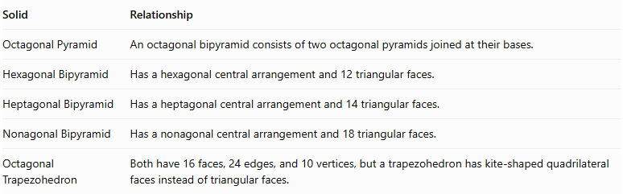
Solid | Relationship
Octagonal Pyramid | An octagonal bipyramid consists of two octagonal pyramids joined at their bases.
Hexagonal Bipyramid | Has a hexagonal central arrangement and 12 triangular faces.
Heptagonal Bipyramid | Has a heptagonal central arrangement and 14 triangular faces.
Nonagonal Bipyramid | Has a nonagonal central arrangement and 18 triangular faces.
Octagonal Trapezohedron | Both have 16 faces, 24 edges, and 10 vertices, but a trapezohedron has kite-shaped quadrilateral faces instead of triangular faces.

Worked Examples

Example 1: Calculate the Number of Faces, Edges, and Vertices
# Source: AI Source: Provided by: [Data Path: Persons Table -> ID Column: 1, Name_En Column: Motasem Essam] -> From: [ChatGPT] on [7/25/2026]
Given: An octagonal bipyramid has an octagonal central arrangement.
For an $n$-gonal bipyramid:
$$F=2n, E=3n, V=n+2$$
Since $n=8$:
$$F=2(8)=16$$
$$E=3(8)=24$$
$$V=8+2=10$$
Answer:
- Faces = 16
- Edges = 24
- Vertices = 10

Example 2: Calculate the Volume
# Source: AI Source: Provided by: [Data Path: Persons Table -> ID Column: 1, Name_En Column: Motasem Essam] -> From: [ChatGPT] on [7/25/2026]
Given:
- Area of the octagonal base: $B=100{ cm}^{2}$
- Upper pyramid height: $h_{u}=12 cm$
- Lower pyramid height: $h_{l}=10 cm$
Using:
$$V=\frac{1}{3}B(h_{u}+h_{l})$$
Substitute:
$$V=\frac{1}{3}(100)(12+10)$$
$$V=\frac{2200}{3}$$
$$\boxed{V≈733.33{ cm}^{3}}$$

Constructing Octagonal Bipyramid in Solid Geometry

Geometric Instruments Used
# Source: AI Source: Provided by: [Data Path: Persons Table -> ID Column: 1, Name_En Column: Motasem Essam] -> From: [ChatGPT] on [7/25/2026]
The construction uses traditional geometric instruments rather than coordinate-based construction.
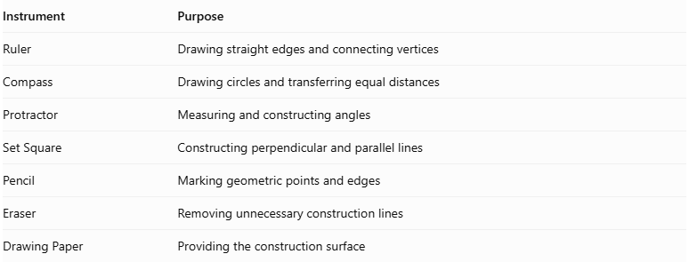
Instrument | Purpose
Ruler | Drawing straight edges and connecting vertices
Compass | Drawing circles and transferring equal distances
Protractor | Measuring and constructing angles
Set Square | Constructing perpendicular and parallel lines
Pencil | Marking geometric points and edges
Eraser | Removing unnecessary construction lines
Drawing Paper | Providing the construction surface

Instrument-Based Construction Procedures

Constructing the Octagonal Base
# Source: AI Source: Provided by: [Data Path: Persons Table -> ID Column: 1, Name_En Column: Motasem Essam] -> From: [ChatGPT] on [7/25/2026]
- Draw a circle using a compass.
- Mark the center of the circle.
- Divide the circle into eight equal angular sections using a protractor.
- Each central angle measures:
$$\frac{{360}^{∘}}{8}={45}^{∘}$$
- Mark the eight points around the circumference.
- Connect consecutive points using a ruler.
- Complete the regular octagonal base.

Constructing the First Pyramid
# Source: AI Source: Provided by: [Data Path: Persons Table -> ID Column: 1, Name_En Column: Motasem Essam] -> From: [ChatGPT] on [7/25/2026]
- Identify the center of the octagonal base.
- Construct a perpendicular line passing through the center of the base.
- Mark the first apex above the base plane.
- Connect the apex to all eight vertices of the octagon.
- Form eight triangular lateral faces.

Constructing the Second Pyramid
# Source: AI Source: Provided by: [Data Path: Persons Table -> ID Column: 1, Name_En Column: Motasem Essam] -> From: [ChatGPT] on [7/25/2026]
- Extend the perpendicular axis through the base plane in the opposite direction.
- Mark the second apex below the base plane.
- Connect the second apex to all eight vertices of the octagon.
- Form another eight triangular lateral faces.

Completing the Bipyramid
# Source: AI Source: Provided by: [Data Path: Persons Table -> ID Column: 1, Name_En Column: Motasem Essam] -> From: [ChatGPT] on [7/25/2026]
- Check that both pyramids share the same octagonal base.
- Ensure that the two apices are on opposite sides of the base plane.
- Darken the visible external edges.
- Represent hidden edges using dashed lines when necessary.
- Remove unnecessary construction marks.
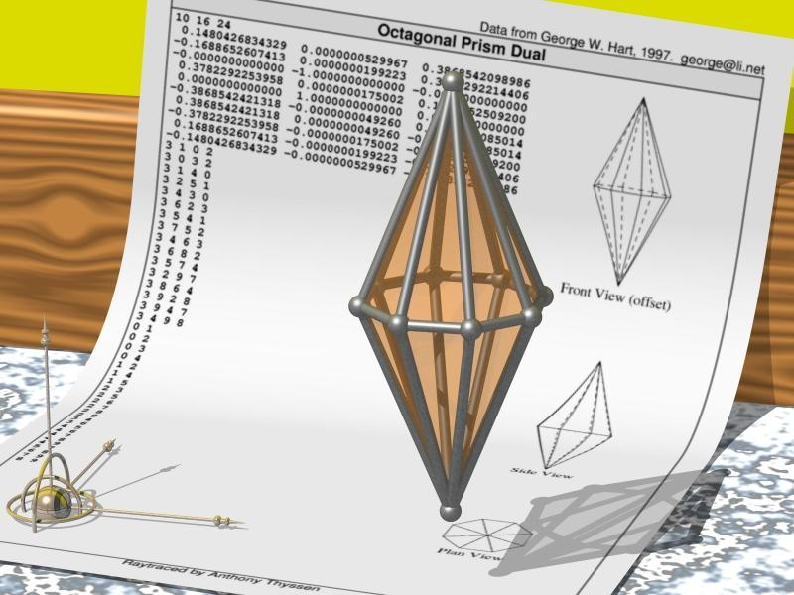

Key Points
# Source: AI Source: Provided by: [Data Path: Persons Table -> ID Column: 1, Name_En Column: Motasem Essam] -> From: [ChatGPT] on [7/25/2026]
- An octagonal bipyramid is formed by joining two octagonal pyramids at their bases.
- It has 16 external triangular faces.
- It has 24 edges.
- It has 10 vertices.
- Its common octagonal base is internal and is not counted as an external face.
- Its volume is the sum of the volumes of the two octagonal pyramids.
- A regular symmetric octagonal bipyramid has eightfold rotational symmetry.

Conclusion
# Source: AI Source: Provided by: [Data Path: Persons Table -> ID Column: 1, Name_En Column: Motasem Essam] -> From: [ChatGPT] on [7/25/2026]
The Octagonal Bipyramid is a polyhedron formed by combining two octagonal pyramids around a shared octagonal base. It belongs to the family of $n$-gonal bipyramids and has 16 triangular faces, 24 edges, and 10 vertices.
Its defining characteristic is the eight-sided central arrangement connecting the upper and lower apexes.

